Exp No:2 Upload and Analyze the data set given in csv format and perform data
preprocessing and visualization.
Code:
import matplotlib.pyplot as plt
import numpy as np
import pandas as pd
import seaborn as sns

# Load the data into a pandas DataFrame
# Note: If your text file uses tabs instead of commas, change to pd.read_csv(file_path, sep='\t')
file_path = 'Sales_data.csv.xls'
df = pd.read_csv(file_path)

# Display the first few rows of the DataFrame
print(df.head())

# Check for missing values
print(df.isnull().sum())

# Fill or drop missing values if necessary
df["Sales"] = df["Sales"].fillna(df["Sales"].mean())
df.dropna(subset=["Product", "Quantity", "Region"], inplace=True)

# Summary statistics
print(df.describe())

# Group by product and calculate the total sales and quantity
product_summary = (
df.groupby("Product").agg({"Sales": "sum", "Quantity": "sum"}).reset_index()
)
print(product_summary)

# Bar plot of total sales by product
plt.figure(figsize=(10, 6))
plt.bar(product_summary["Product"], product_summary["Sales"])
plt.xlabel("Product")
plt.ylabel("Total Sales")
plt.title("Total Sales by Product")
plt.show()

# Line plot of sales over time
df["Date"] = pd.to_datetime(df["Date"])
sales_over_time = df.groupby("Date").agg({"Sales": "sum"}).reset_index()
plt.figure(figsize=(10, 6))
plt.plot(sales_over_time["Date"], sales_over_time["Sales"])
plt.xlabel("Date")
plt.ylabel("Total Sales")
plt.title("Sales Over Time")
plt.show()

# Pivot table to analyze sales by region and product
pivot_table = df.pivot_table(
values="Sales", index="Region", columns="Product", aggfunc="sum", fill_value=0
)
print(pivot_table)

# Correlation matrix (Fixed: explicitly selecting only numeric columns)
correlation_matrix = df[["Sales", "Quantity"]].corr()
print(correlation_matrix)

# Heatmap of the correlation matrix
plt.figure(figsize=(8, 6))
sns.heatmap(correlation_matrix, annot=True, cmap="coolwarm")
plt.title("Correlation Matrix")
plt.show()
output:
Date Product Sales Quantity Region
0 2023-01-01 Product A 200 4 North
1 2023-01-02 Product B 150 3 South
2 2023-01-03 Product A 220 5 North
3 2023-01-04 Product C 300 6 East
4 2023-01-05 Product B 180 4 West
Date 0
Product 0
Sales 0
Quantity 0
Region 0
dtype: int64
Sales Quantity
count 16.000000 16.000000
mean 237.500000 5.375000
std 49.598387 1.454877
min 150.000000 3.000000
25% 207.500000 5.000000
50% 220.000000 5.000000
75% 277.500000 5.250000
max 320.000000 8.000000
Product Sales Quantity
0 Product A 1350 33
1 Product B 850 17
2 Product C 1600 36
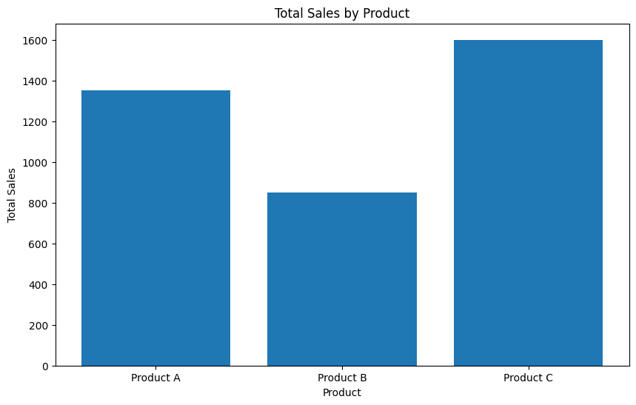
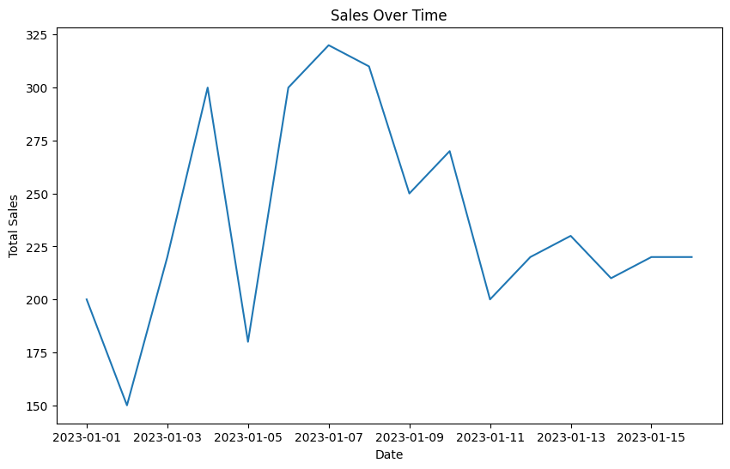
Product A Product B Product C
Region
East 310 0 740
North 720 0 410
South 320 420 220
West 0 430 230
Sales Quantity
Sales 1.000000 0.910021
Quantity 0.910021 1.000000
